Suicide Risk & Crisis Support

Check out these sources for resources for assessing, managing, and treating suicidality.

Immediate Crisis Support

https://988lifeline.org/

Call or text 988 to reach the 988 Lifeline for immediate, confidential crisis support for you or a loved one.

Veterans Crisis Line

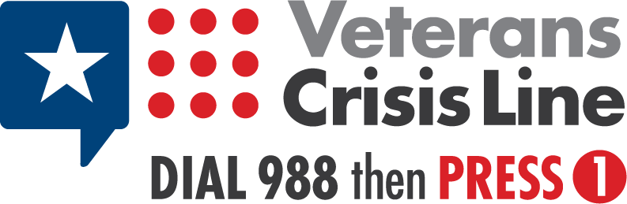

https://www.veteranscrisisline.net/

Immediate, confidential crisis support for military veterans and their loved ones.

American Foundation for Suicide Prevention

https://afsp.org/get-help/

For immediate personal assistance and professional suicide prevention resources, check out the American Foundation for Suicide Prevention. They also conduct regular “research round-ups” to collect the latest research on suicide prevention

Assessment Tools
The Columbia Lighthouse Project
https://cssrs.columbia.edu/
The Columbia Protocol (C-SSRS) is a free, easily downloadable suicidal risk assessment tool that can be used by anyone. It has an accompanying APP and guides you can download at the website.

Zero Suicide Framework Tools

https://zerosuicide.edc.org/about/framework

The Zero Suicide framework is an aspirational model containing seven essential elements in suicide prevention care: Lead, Train, Identify, Engage, Treat, Transition, and Improve.

Check out the Zero Suicide Toolkit, which has adaptations for children’s hospitals and indigenous people (Indian Country):
https://zerosuicide.edc.org/toolkit/toolkit-adaptations

Suicide Prevention Resource Center
https://sprc.org/
The Suicide Prevention Resource Center gathers promising and evidence-based suicide prevention treatments for mental health practitioners, organizational policy makers, and researchers. They also offer online courses on important topics to improve suicide prevention.

American Association of Suicidology (AAS)
https://suicidology.org/
The American Association of Suicidology provides comprehensive resources to help navigate your journey with suicide and mental health. They have a peer-reviewed journal and an annual conference to provide up-to-date treatments, resources, and research into understanding and treating suicidology.

